Chatbot using LangGraph

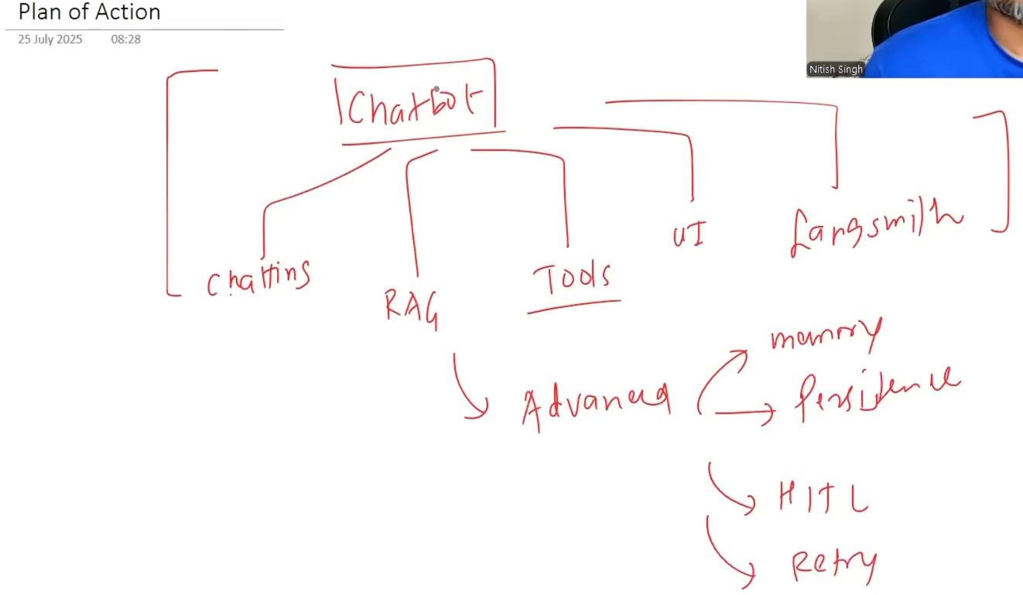
Code:-
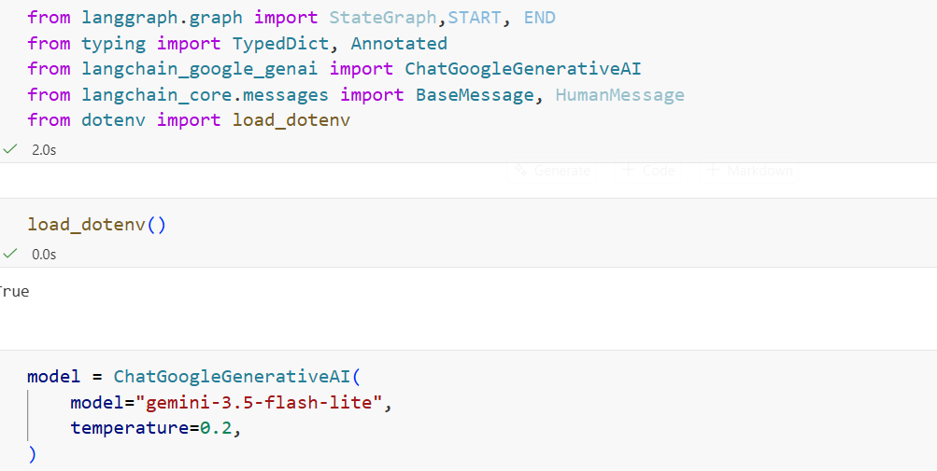

Here we have message as base message.BaseMessage is the base class/interface for all message types in LangChain. HumanMessage, AIMessage, SystemMessage, and ToolMessage are specialized message types built from it. We are saying the message can contain all of these messages.
- HumanMessage → Message/input from the user.
- AIMessage → Response generated by the LLM.
- SystemMessage → Gives the LLM instructions, role, or behavior.
- ToolMessage → Contains the result/output from a tool called by the LLM.
add_messages is a specialized reducer in LangGraph for handling message lists. It is more optimized and suitable for chat history than using the regular operator.add.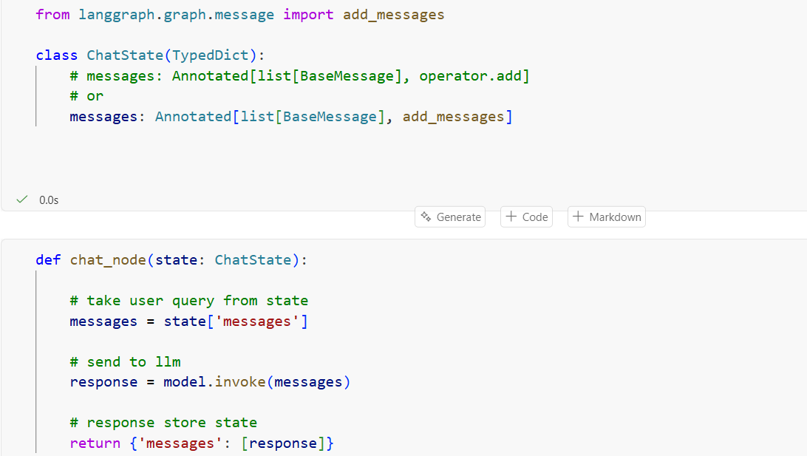
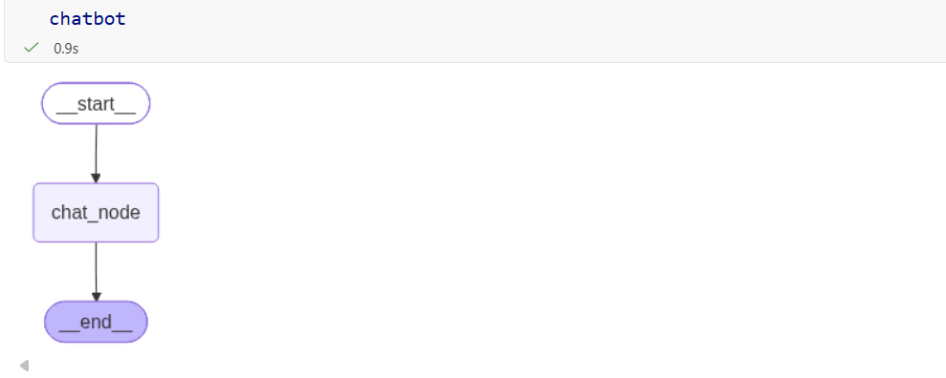
But this is just a one time chat and You have to manually provide the messages each time:
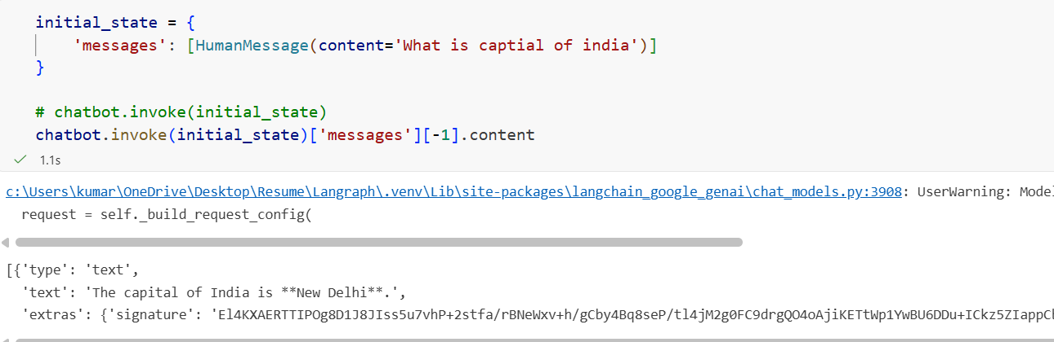

We use a while loop so the user can keep chatting until they enter exit, bye, or quit.
The problem is that without persistence, the chatbot has no memory of previous conversations. Each time the loop runs, chatbot.invoke() starts a new graph execution, so the previous state is not available.
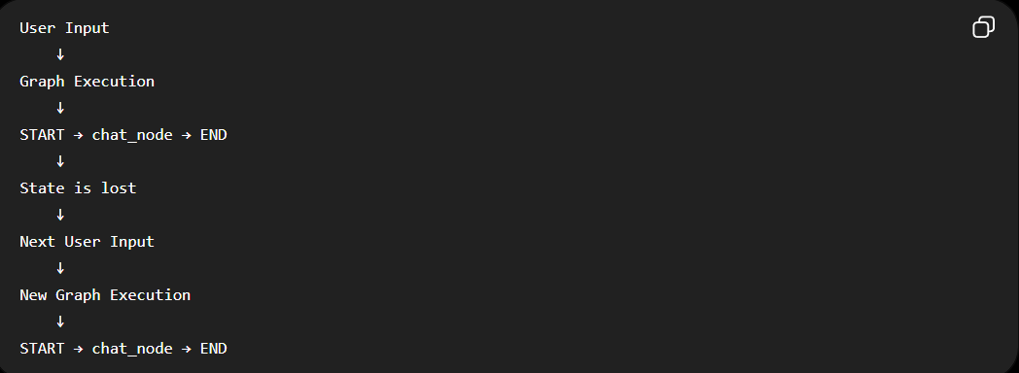 So, even if we add messages to the state, they are only available during that particular graph execution.
We solve this problem using Persistence in langraph. Persistence means saving the graph's state so it can be stored and retrieved later, allowing workflows to continue across executions.
Persistence means that even after the graph reaches END, its state is not lost. A checkpointer saves the state in memory or a database so it can be retrieved in the next graph execution.
Here, we use MemorySaver, which keeps the state in memory while the program is running. In real-world applications, database-backed persistence is more commonly used because the data can survive beyond the program's lifetime.
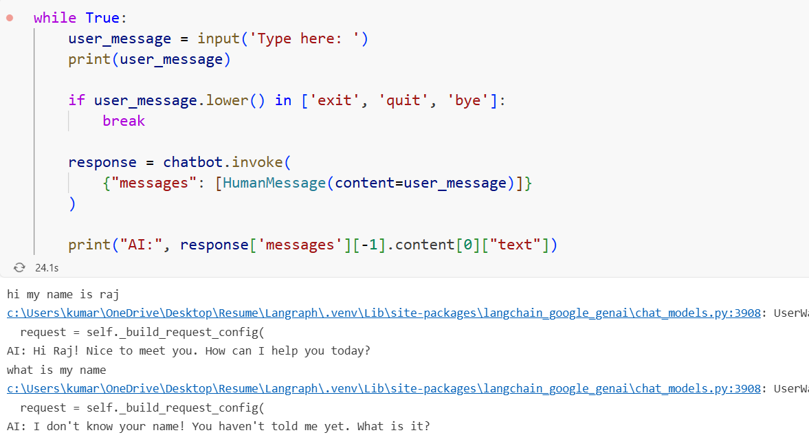

We add a memory saver at the import for persistence
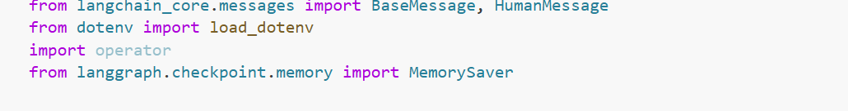
We create a checkpointer to store the graph's state and pass it during compilation using checkpointer.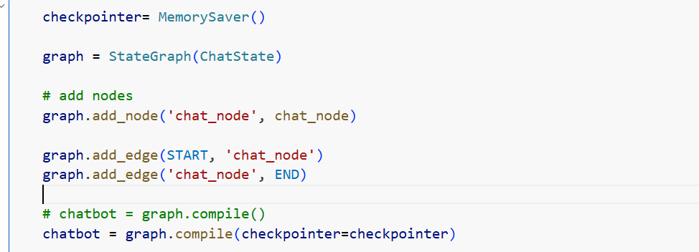
thread_id identifies a particular conversation/session so LangGraph knows which state or memory belongs to it.
Intuition: Think of it as a conversation ID. thread_id = 1 and thread_id = 2 represent two separate conversations.
config tells LangGraph which conversation's state should be loaded and saved during execution.
config = {
"configurable": {
"thread_id": thread_id
}
}
Intuition: thread_id is the ID, while config is the instruction that tells LangGraph to use that ID. As we can see, it can remember our chat now.

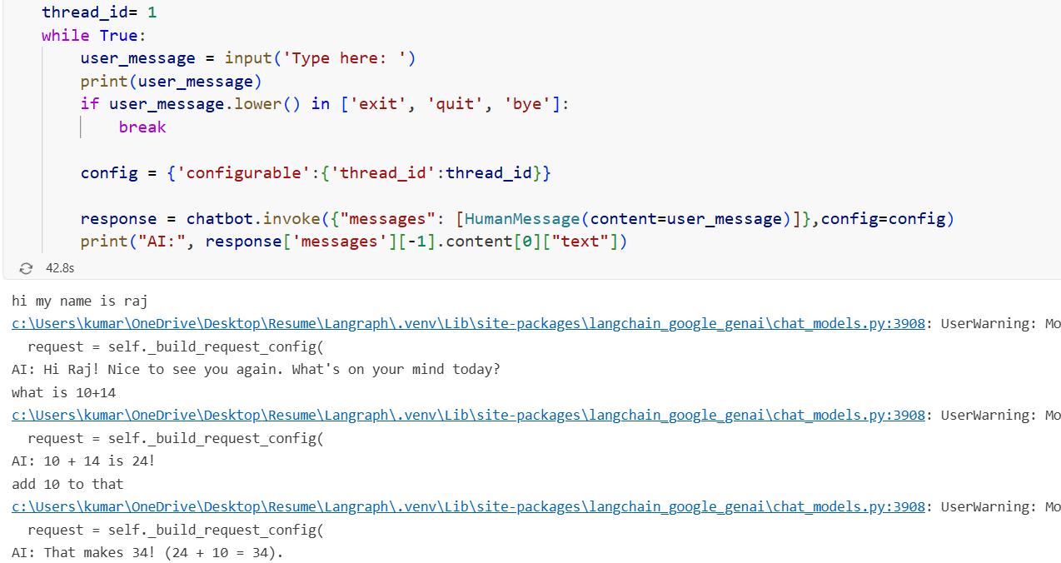

MemorySaver stores the graph state in RAM while the program is running. When a new message arrives with the same thread_id, LangGraph retrieves the previous state and combines it with the new input, giving the chatbot the previous conversation as context.
However, MemorySaver is temporary. If you restart the program, notebook/kernel, or application, the in-memory state is lost.
For production applications, a database-backed checkpointer is generally better because the state can persist even after the application restarts.
